**DAILY ONLINE ACTIVITIES SUMMARY**

|  |  |  |  |  |  |  |  |  |
| --- | --- | --- | --- | --- | --- | --- | --- | --- |
| **Date:** | **26/05/2020** | | | | | **Name:** | **AKASH S** | |
| **Sem & Sec** | **4TH&A** | | | | | **USN:** | **4AL18CS004** | |
| **Online Test Summary** | | | | | | | | |
| **Subject** | | **DESIGN AND ANALYSIS OF ALGORITHM** | | | | | | |
| **Max. Marks** | | **30** | | **Score** | | | **25** | |
| **Certification Course Summary** | | | | | | | | |
| **Course** | **JAVA PROGRAMMING** | | | | | | | |
| **Certificate Provider** | | | **GREATLEARNING** | | **Duration** | | | **3.5 HOURS** |
| **Coding Challenges** | | | | | | | | |
| **Problem Statement:1:** | | | | | | | | |
| **Status: executed** | | | | | | | | |
| **Uploaded the report in Github** | | | | | **YES** | | | |
| **If yes Repository name** | | | | | **1.https://github.com/akashacharya786/lockdown-coding/blob/master/Palidrome**  **2.** **https://github.com/akashacharya786/lockdown-coding/blob/master/Palidromestack.java** | | | |
| **Uploaded the report in slack** | | | | | **YES** | | | |

Online Test Summary:

18CS42 the test was from 2nd module about divide and conquer. There are 30 questions and the duration 30minutes.The score that I received was 25/30.



Online Certification course:

Today I started a new certification course

Name of the course :Java programming

Duration:3.5 hours

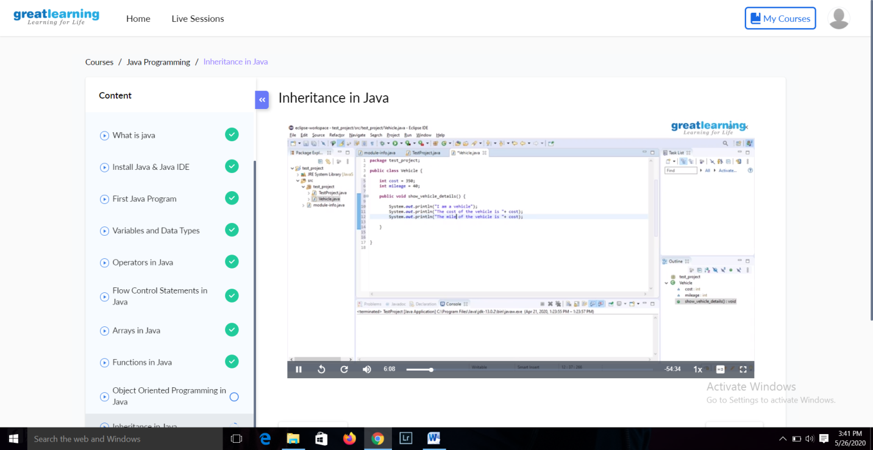

Online Coding summary:

1.We have a Letter or a word then we need add some letters to it and need to find out shortest palindrome  
For example we take "S": S will be the shortest palindrome string.  
If we take "xyz": zyxyz will be the shortest palindrome string  
So we need to add some characters to the given string or character and find out what will be the shortest palindrome string by using simple java program.

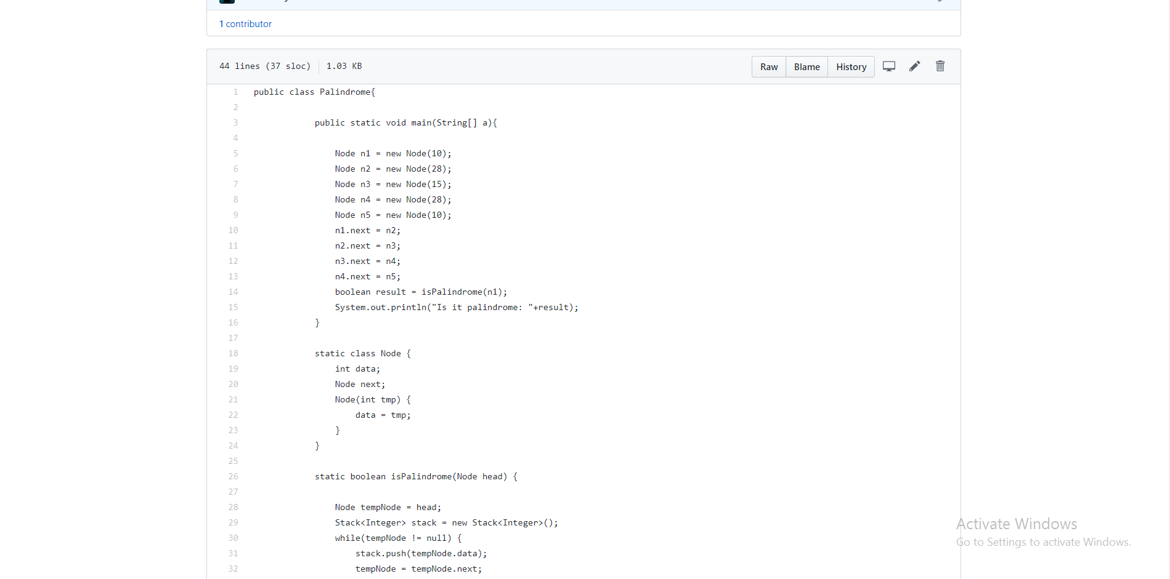

This the snap shot of the first program

2. Write a simple code to identify given linked list is palindrome or not by using stack.  
First take a Stack. Traverse through each node of the linked list and push each node value to Stack.  
Once the traversal & copying is done, iterate through linked list from head node again.  
In each iteration, pop one stack element and compare with node value in respective iteration. It is expected to match stack popped value with node value.  
In case of all matches, its a palindrome. Any one element mismatch makes it not a palindrome.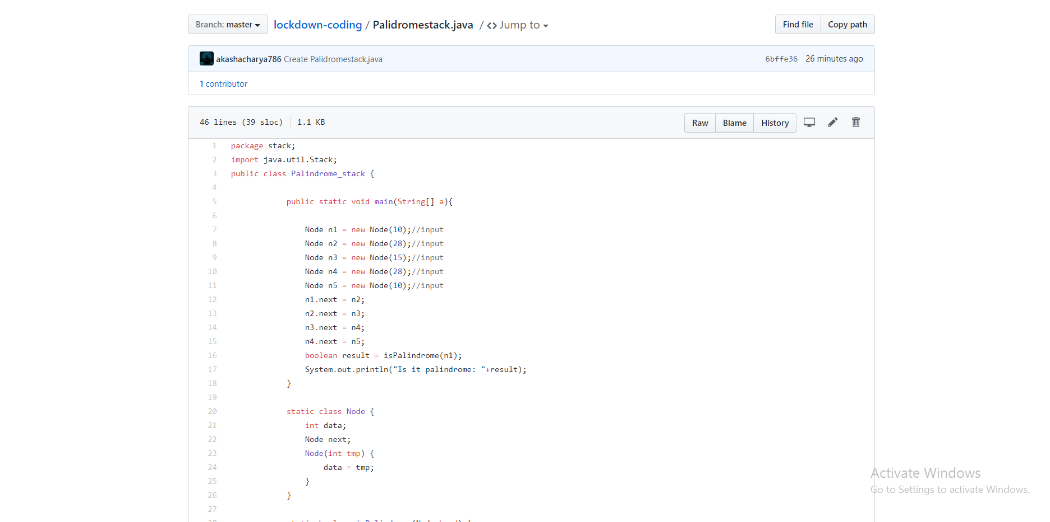

This the snapshot of the 2 program